Systems Analysis

and Design

Instructor : Huang, Chuen-Min

**Teamwork ver.1**

Group 4

|  |  |
| --- | --- |
| ID | Name |
| B10423011 | Lily |
| B10423034 | Ging |
| B10523004 | Rick |
| B10523007 | Bess |
| B10523032 | Xavier |
| B10523034 | Kenny |
| B10523057 | Helen |
| A10523050 | Ian |
| X10698051 | Andy |
| Date 2018/05/08 | |

**Contents**

**1.Describe the project in text.** 3

**2.Use case diagram** 4

**3.Use case description** 5

**4.Activity diagram** 7

**5.Sequence diagram** 10

**6.Class diagram** 14

**7. state machine** 15

Please discuss a team project that your team members agree to work, and do the following:

1. **Describe the project in text.**

Have you ever experienced a situation where you want to turn on the air conditioner but the remote control is missing, or you want to turn off the light but needs to get out of bed first?

There has a solution to help you solve the troubling problem – Voice Assistant. The setting step is easy to do. You name the voice assistant like "Little Black", then add or delete the equipment you want to connect to, such as air conditioner, television, electric light, etc. Finally, set it with specific instruction.

Suppose you have a need to turn on the air conditioner. First, you wake up the voice assistant by calling for "Little Black". It will return the response if it works normally. Next, saying "Turn on the air conditioner" then voice assistant will connect to air conditioner and operate the instruction automatically.

Also, you can lie on the bed relaxedly, and ask the voice assistant for turning on/off the television or the electric light. Then all things will be well controlled.

1. **Draw a use case diagram of the project.**

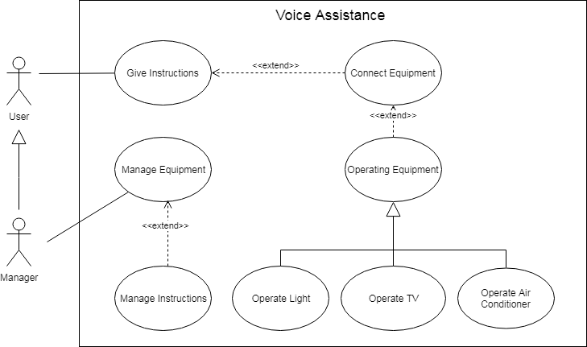

**3. Create a use case description and describe the normal flow of events, subflows, alternate/Exception flows for one of the most important functions of the project.**

|  |  |  |  |
| --- | --- | --- | --- |
| **Use Case Name：**Give instructions | | **ID：**1 | **Importance Level：**High |
| **Primary Actor：**User | **Use Case Type：**Detail, Essential | | |
| **Stakeholders and Interests：**  User – wants to use Voice Assistant for open or close equipment. | | | |
| **Brief Description：**This use case describes how the system use voice to control the equipment. | | | |
| **Trigger：**User wants to use equipment will through this use case.  **Type：**External | | | |
| **Relationships：**  Association：  Include：  Extend：connect equipment  Generalization： | | | |
| **Normal Flow of Events：**   1. The User calls Voice Assistant. 2. The Voice Assistant gets voice. 3. The Voice Assistant speech voice to Text. 4. The Voice Assistant identify Text is key word or not.   If the identification is key word.  go to Step 5.  If the identification is not key word.  the S-1:The Voice Assistant stop the interaction.   1. The Voice Assistant males a voice like “Bee”. 2. The User has given an instruction in 10 seconds or not.   If has given in 10 seconds.  go to Step 7.  If has not given in 10 seconds  the S-1:The Voice Assistant stop the interaction.   1. The Voice Assistant gets voice. 2. The Voice Assistant speech voice to Text. 3. The Voice Assistant identify equipment from Text.   If there is the equipment.  go to Step 10.  If there is not the equipment.  The S-2:The Voice Assistant displays “Didn’t have this instruction.”.   1. The Voice Assistant connect the equipment.   If can connect the equipment.  If connect with Air Conditioner.  go to Step 11.  If connect with Light.  go to Step 12.  If connect with TV.  go to Step 13.  If can not connect the equipment.  The S-3:The Voice Assistant displays “Connect error.”   1. The Voice Assistant identify action for Air Conditioner.   If there has action for Air Conditioner.  If action is set temperature for Air Conditioner, the Voice Assistant adjust temperature.  If action is set wind speed for Air Conditioner, the Voice Assistant adjust wind speed.  If action is open or close Air Conditioner.  If the action open, the Voice Assistant open the Air conditioner.  If the action close, the Voice Assistant close the Air conditioner.  If there doesn’t have action.  The S-2:The Voice Assistant displays “Didn’t have this instruction.”.   1. The Voice Assistant identify action for Light.   If there has action for Light.  If action is open or close Light.  If the action open, the Voice Assistant open the Light.  If the action close, the Voice Assistant close the Light.  If there doesn’t have action.  The S-2:The Voice Assistant displays “Didn’t have this instruction.”.   1. The Voice Assistant identify action for TV.   If there has action for TV.  If action is set volume for TV, the Voice Assistant adjust volume.  If action is set channel for TV, the Voice Assistant adjust channel.  If action is open or close TV.  If the action open, the Voice Assistant open the TV.  If the action close, the Voice Assistant close the TV.  If there doesn’t have action.  The S-2:The Voice Assistant displays “Didn’t have this instruction.”. | | | |
| **SubFlows：**  S-1: The Voice Assistant stop the interaction.  S-2: The Voice Assistant displays “Didn’t have this instruction.”.  S-3: The Voice Assistant displays “Connect error.”. | | | |
| **Alternate/Exceptional Flow：** | | | |

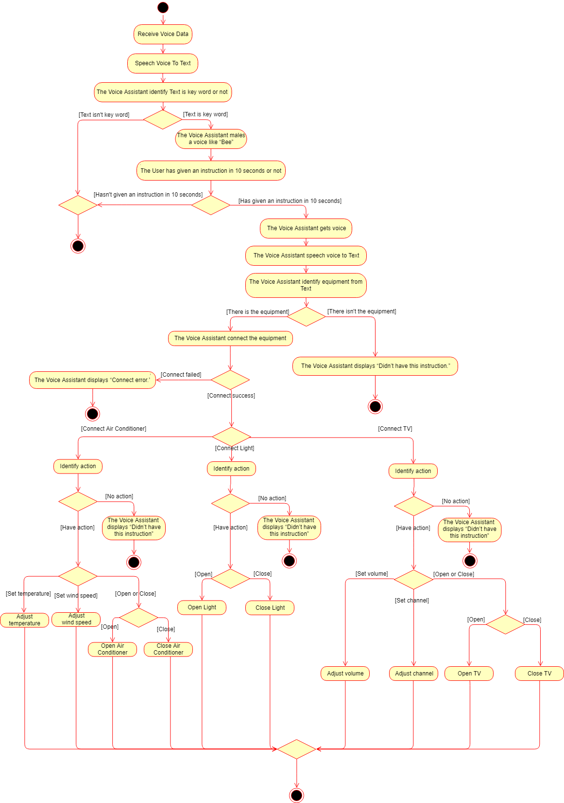**4. Draw an activity diagram to depict the use case you selected from question 2 or some aspects of the system.**

**  
**

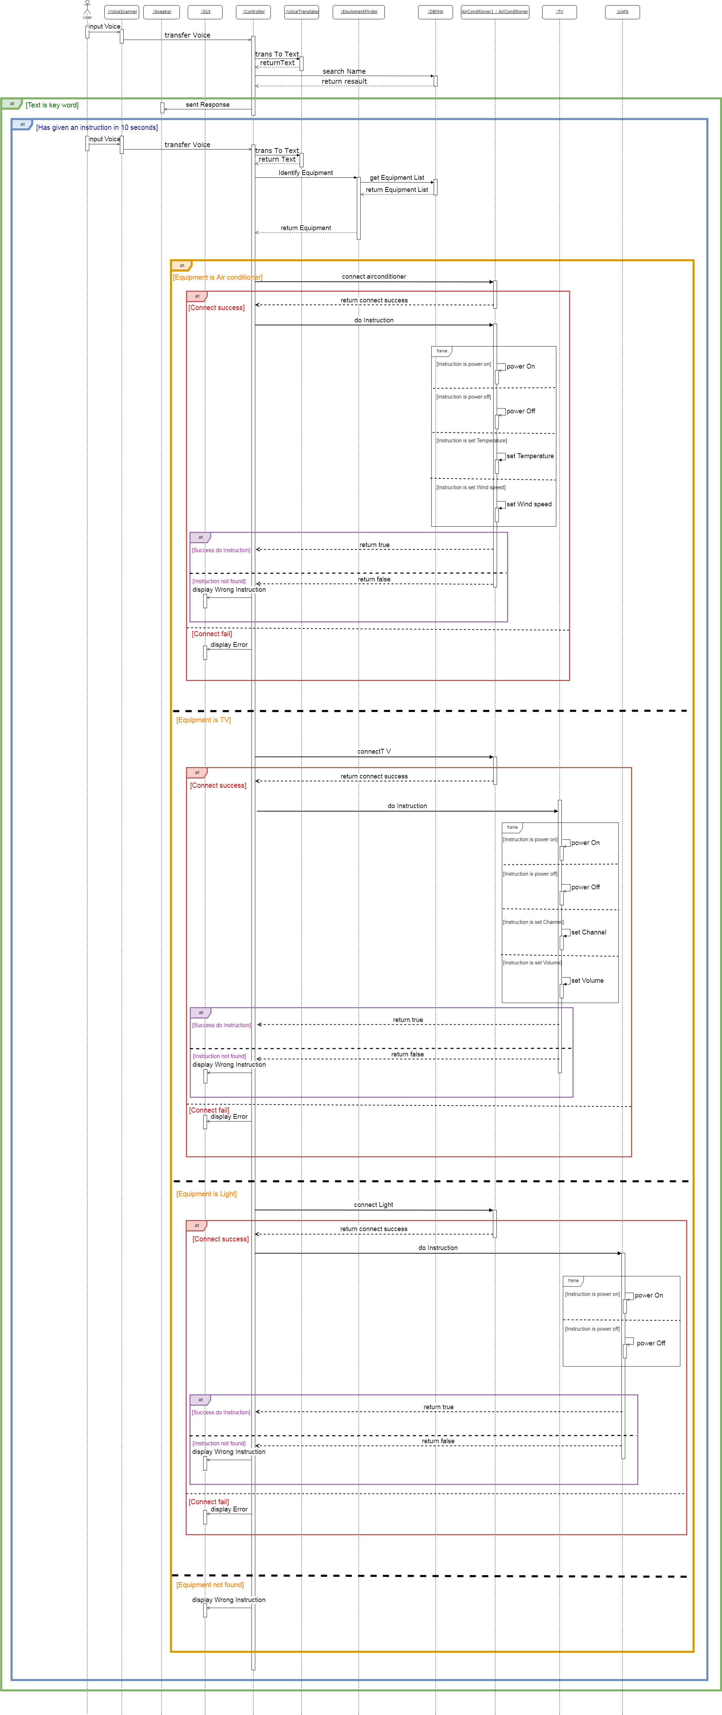**5. Draw a detailed sequence diagram based on the use case you selected, or some aspects of the system.**







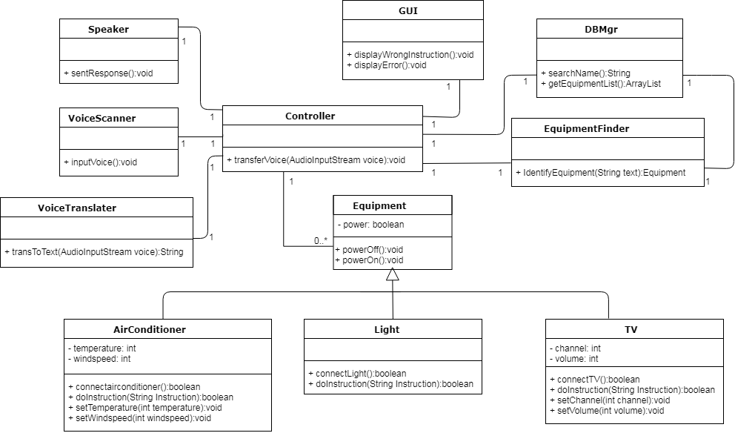**6. Based on the sequence diagram you have finished, please draw a class diagram with necessary attributes and operations in each class.**

**7. Draw a behavior state machine to depict an important class or the system as it goes through the whole process.**

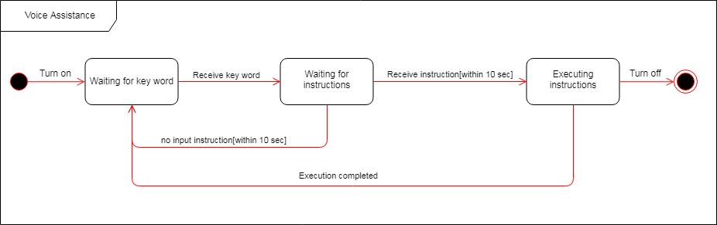

|  |  |  |  |
| --- | --- | --- | --- |
| **ID** | **Name** | **Score** | **Work** |
| B10423011 | Lily | 100 | Participate in discussions, Use case description, Class diagram |
| B10423034 | Ging | 100 | Participate in discussions, Sequence diagram, Class diagram |
| B10523004 | Rick | 100 | Participate in discussions, Activity diagram, Sate machine |
| B10523007 | Bess | 100 | Participate in discussions, Use case description, Class diagram |
| B10523032 | Xavier | 100 | Participate in discussions, Sate machine, Context |
| B10523034 | Kenny | 100 | Participate in discussions, Activity diagram, Sate machine |
| B10523057 | Helen | 100 | Participate in discussions, Activity diagram, Sate machine |
| X10698051 | Andy | 100 | Participate in discussions, Activity diagram, Context |
| A10523050 | Ian | 100 | Participate in discussions, Use case diagram, PPT |

**Assignments and participation**